For Sale:
2014 Mercedes-Benz Sprinter 2500 BlueTec Conversion Van (Class B Campervan)
Hurst, Texas
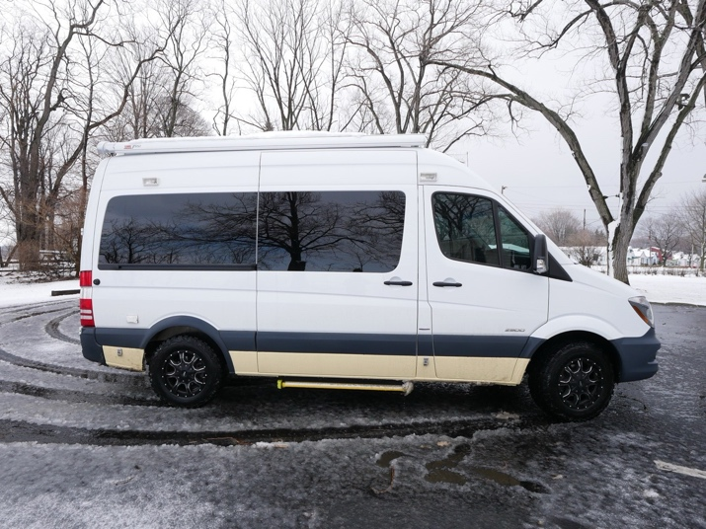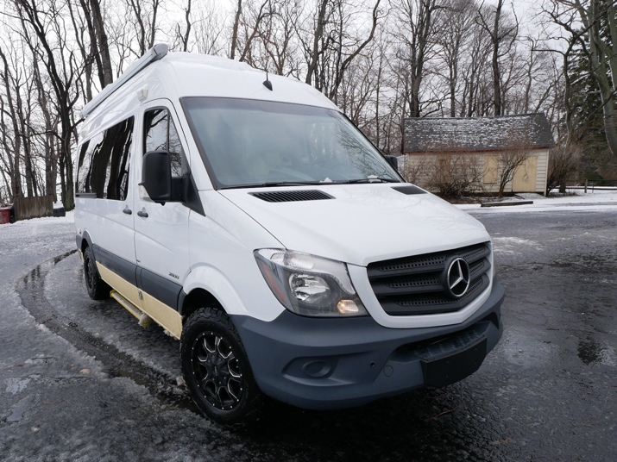
Overview:
Embrace the spirit of adventure with our professionally converted 2014 Mercedes-Benz Sprinter 2500 BlueTec Conversion Van. Expertly outfitted by Creative Mobile Interiors (Columbus, Ohio) and Ilderton Conversion Company (Charlotte, North Carolina), this Class B campervan was built for extended travel, self-sufficiency, and life on the road.
We purchased the van in 2018 and used it extensively for travel and full-time living for roughly two years, taking it all the way to Northern Canada, into Mexico, and across the United States. Since 2023, it has seen very limited use. As our family has now grown to six, we’ve moved up to a larger RV and are ready to pass this van on to its next owner.
This Sprinter is designed for the ultimate wanderer: it fits in a standard parking space, offers full standing room, and includes a diesel high-idle feature that allows you to operate without shore power or a generator—making it ideal for remote travel, boondocking, or long-term living.

Key Features:
- Mileage: Just over 76,000 miles on a 2.1-liter, 4-cylinder turbo diesel BlueTec engine. These engines are known for longevity, often running hundreds of thousands of miles. Fuel economy averages ~21.5 mpg, keeping long-distance travel affordable.
- Size & Convenience:
  - 19.5 ft long (shortest Sprinter available)
  - Fits in a standard parking spot
  - Tallest Sprinter roof height, with full standing room throughout
  - Diesel high-idle eliminates the need for generators or constant hookups
- Recent Upgrades & Replacements:
  - Brand new battery installed (2026)
  - New all-terrain tires (2024)
  - Completely new and unused water system (2023): freshwater tank, toilet, pump, black & gray tanks, plumbing, and drainage
  - Front windshield replaced (2022)
  - Entire diesel exhaust system replaced (2020)
- Professional Conversion:
High-quality, professionally executed conversion designed for durability and real-world use.
- Interior & Build Value:
  - Original Sprinter MSRP: $51,339
  - Over $9,200 in documented interior upgrades
  - Electrical system with automatic switching between engine, battery, or shore power
  - TV, satellite antenna, microwave, refrigerator, shower, toilet, roof exhaust fan, screened door, and extensive built-in storage
- Technology & Comfort:
  - Large navigation screen with Apple CarPlay & Bluetooth
  - Integrated side and rear cameras
  - Electric awning with LED side lighting
  - High-end window shades with blackout and privacy options

Condition:
- Interior Wear & Tear:
This van shows signs of a well-traveled life, primarily cosmetic. There are some upholstery tears in rear trim, peeling faux leather on the rear jackknife sleeper sofa, and broken plastic around a few buttons and switches from normal use over time.
The sofa and refrigerator are fully functional, though the fridge currently sits on an unfinished wood platform rather than a professionally finished cabinet. These elements are easy to replace or redesign, giving a new owner a clean slate to customize the rear living area to their own taste and needs. The van is priced accordingly and sold as-is with this flexibility in mind.
- Exterior:
Glossy white finish in very good condition, professionally detailed. Equipped with Moto Metal wheels and new all-terrain tires (2024).
- Mechanical & Maintenance:
Regularly serviced throughout ownership. The van drives well, is mechanically solid, and is ready to travel immediately. Service records available upon request.

Sale Details:
- Appraised Value (2018): $85,000
- Asking Price (2025): $49,000 (or best offer)
- Ownership History:
We are the third owners. The van was used for full-time solo living and extended travel earlier in our ownership, lightly used since 2023, and is now being sold due to our transition to a larger RV as a family of six.

Venture into the vastness of North America and beyond with this Mercedes-Benz Sprinter Conversion Van. It’s more than a vehicle—it’s a proven, road-tested home on wheels, offered at a price that reflects both its history and its potential. We’ve loved it, trusted it, and are excited to see it continue its story with someone new.
Contact Us:
Andrew & Shannon
📧 srames12@gmail.com
📞 315.534.8283
Notes:
- Viewings available by appointment
- Full photo gallery and documentation available upon request
- Clean title, no accidents, well-documented history
A solid, professionally converted Sprinter with major systems already refreshed—ready for its next adventure.
